Distance-sampling analysis in Rdistance

Jason D. Carlisle

Wyoming Cooperative Fish & Wildlife Research Unit, University of Wyoming

and

Trent L. McDonald

WEST, Inc.

2/16/2015

# Abstract

# Relation of Rdistance to other distance-sampling options

Program Distance

Unmarked

Other R packages?

# Overview of workflow

First fit detection function using a number of options.

Second, estimate abundance based

# Example data

sparrows.counts:

TranID: The name of each transect surveyed. This site ID serves as the primary key for linking sparrow count data to site-level covariate data.

Number: The number of individual Brewer’s Sparrows detected at each detection event (also called group size).

SightDist: The distance from the observer to the detected sparrow(s) in meters. Measured using a laser rangefinder in the field.

SightAngle: The angle from the line to the detected sparrow(s) in degrees (0-90). Measured using a compass in the field.

sparrows.covs:

TranID: The name of each transect surveyed. This site ID serves as the primary key for linking sparrow count data to site-level covariate data.

SageClass: Sagebrush cover at each transect. Assessed using remotely-sensed shrub cover data (Homer et al. 2012). The mean shrub cover (%) within 100 m of the transect, classified as either High (>10%) or Low (≤10%)

SageCont: Sagebrush cover at each transect. Assessed using remotely-sensed shrub cover data (Homer et al. 2012). The mean shrub cover (%) within 100 m of the transect.

Grouse: Presence of Greater Sage-Grouse at each transect. Assessed by two observers searching for Greater Sage-Grouse fecal pellets within 2 m of the line over the entire length of the transect. Presences are coded as 1, and absences as 0.

# Input Data

## Format of input data

Count data and covariate data should be maintained separately.

Count data should have one row for each detection event, with a column to identify the site, the size of the group detected, and the perpendicular distance from the group to the survey line. Because perpendicular distance is often difficult to measure in the field, the sighting distance and sighting angle can be substituted (and later converted into perpendicular distances with the perp.dists function).

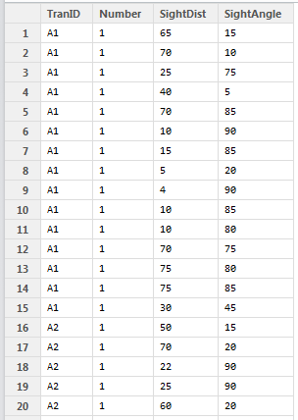

Covariate data should have one row for each site, and one column for each covariate. (Note: Rdistance currently does not support the use of continuous covariates). The site column should be of type factor, with a level for each site.

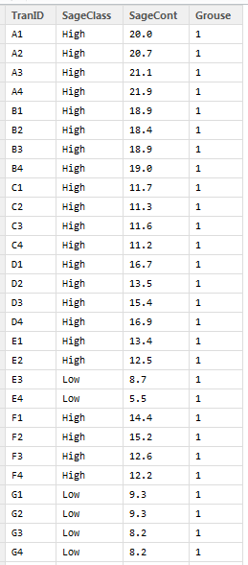

## Sites where no detections were made

## Data exploration and diagnostics

Histogram

Truncate (Pick w.hi and w.lo)

# Fit the detection function

## Automated

## Kernel

## Custom

# Estimate abundance

# Extract and plot results

## Extracting parameters

## Creating plots